**Shopping Cart**

* No product name in response

<http://175.41.176.135:3000/apidoc/#api-Shopping_Cart-GetV1UsersUser_idCart>

**Directory Listing**

* For directory listing using below API

[http://175.41.176.135:3000/apidoc/#api-Business_Directory- GetV1BusinessDirectoriesId](http://175.41.176.135:3000/apidoc/#api-Business_Directory-      GetV1BusinessDirectoriesId)

* Product and services of the directory is not returned in the above API. So another API have to use to get the product and services. But it requires user token

<http://175.41.176.135:3000/apidoc/#api-Products-GetV1ProductsListMe>

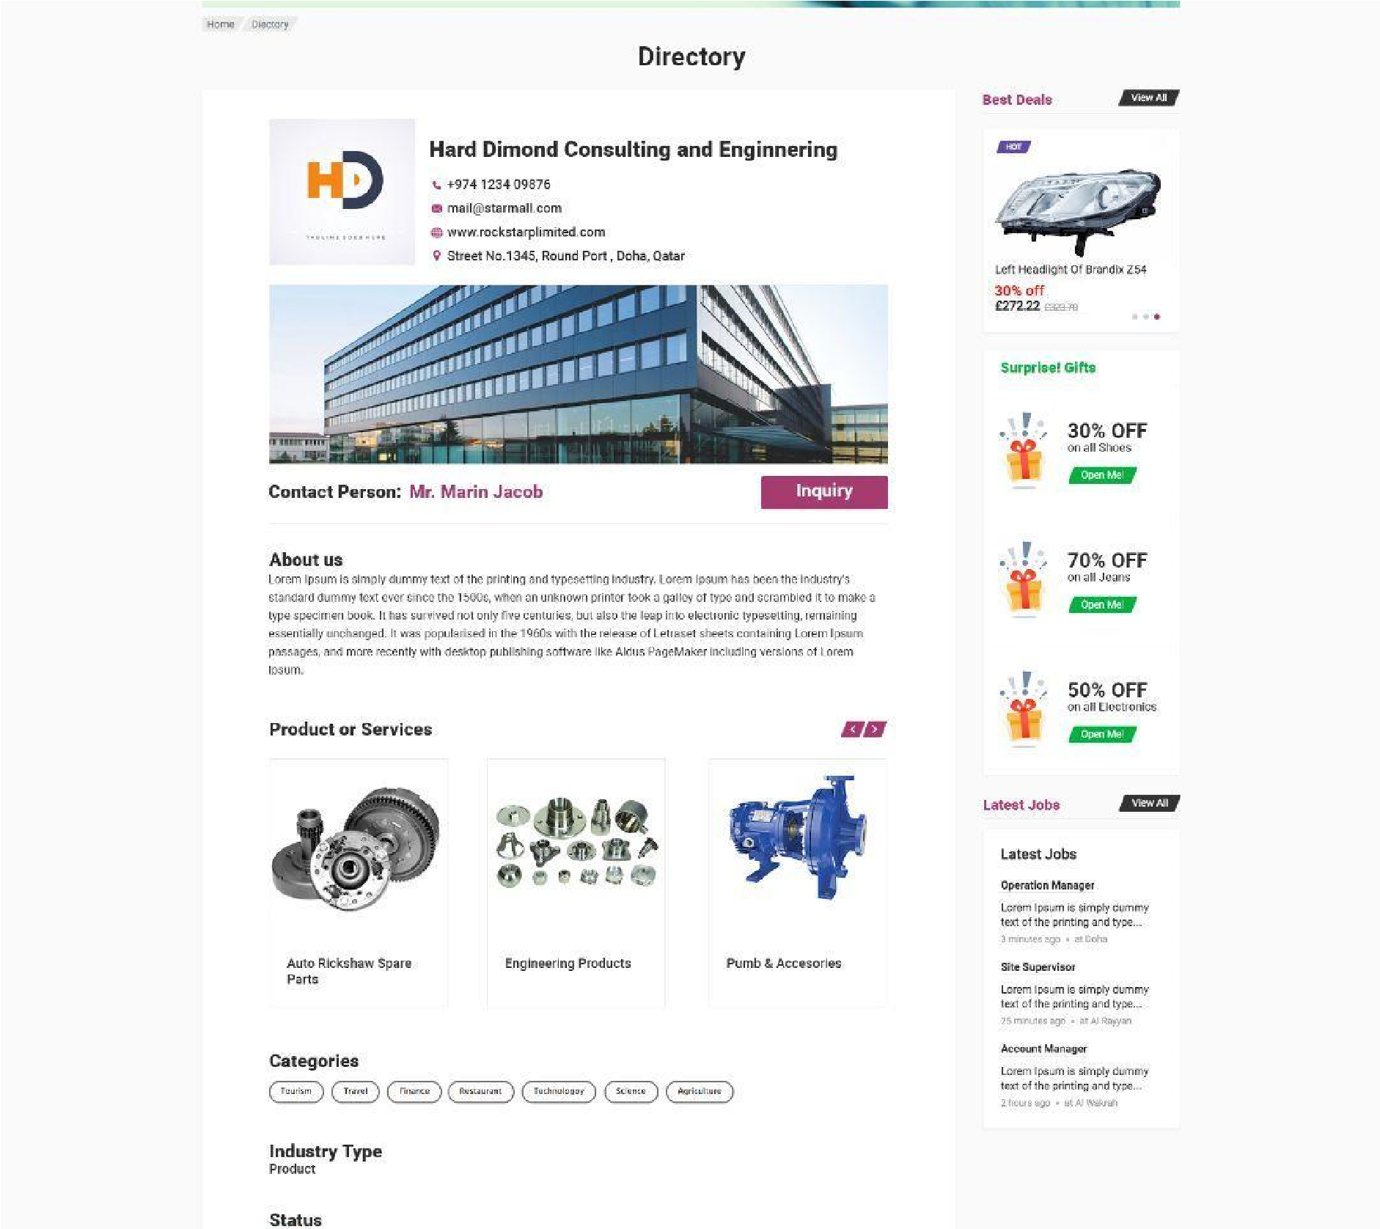

**User Account**

* No separate API for updating the Notification alone

* Location details are not provided, neither in login or in get my profile